


In the Autumn term children will be learning:

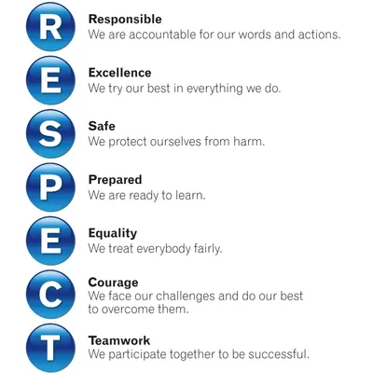  Ethos and Values: |  |  | CoEL:  Playing and exploring  - Finding out and exploring  - Playing with what they know  Active learning  - Being involved and concentrating  - Enjoying achieving what they set out to do  Creating and thinking critically  - Having their own ideas | Childhood Experiences:  - Catch a falling leaf  - Eat an apple straight from a tree  - Find a conker | KSU Passports:  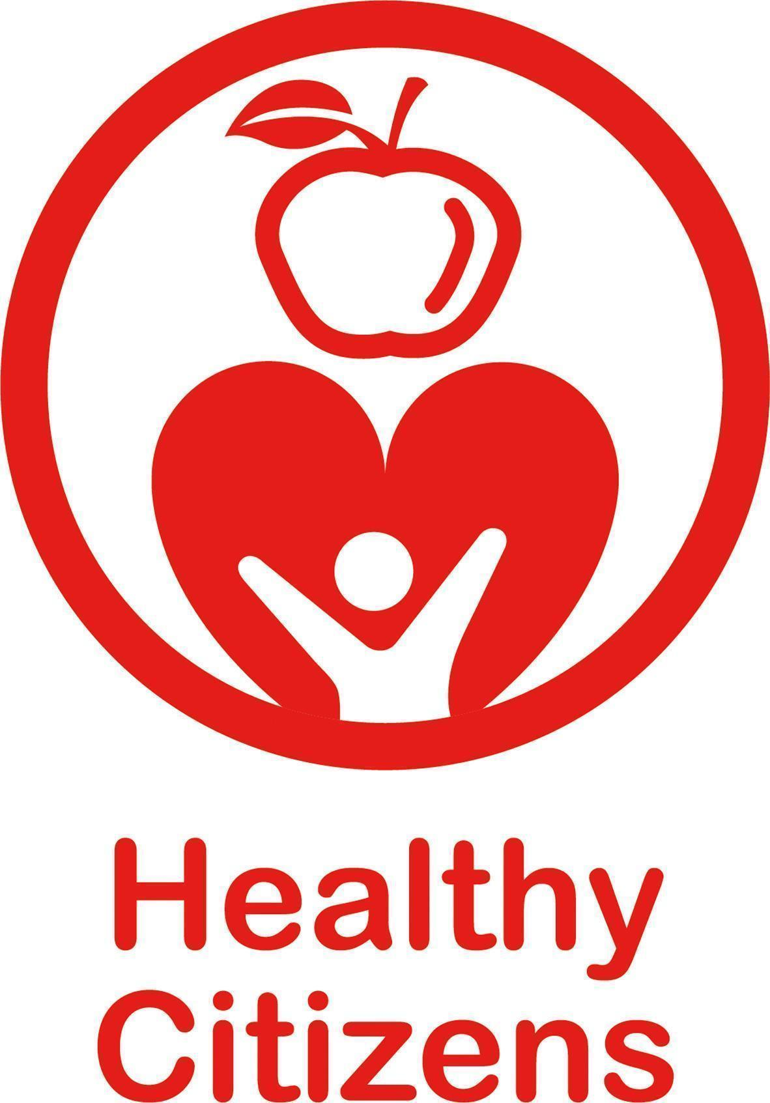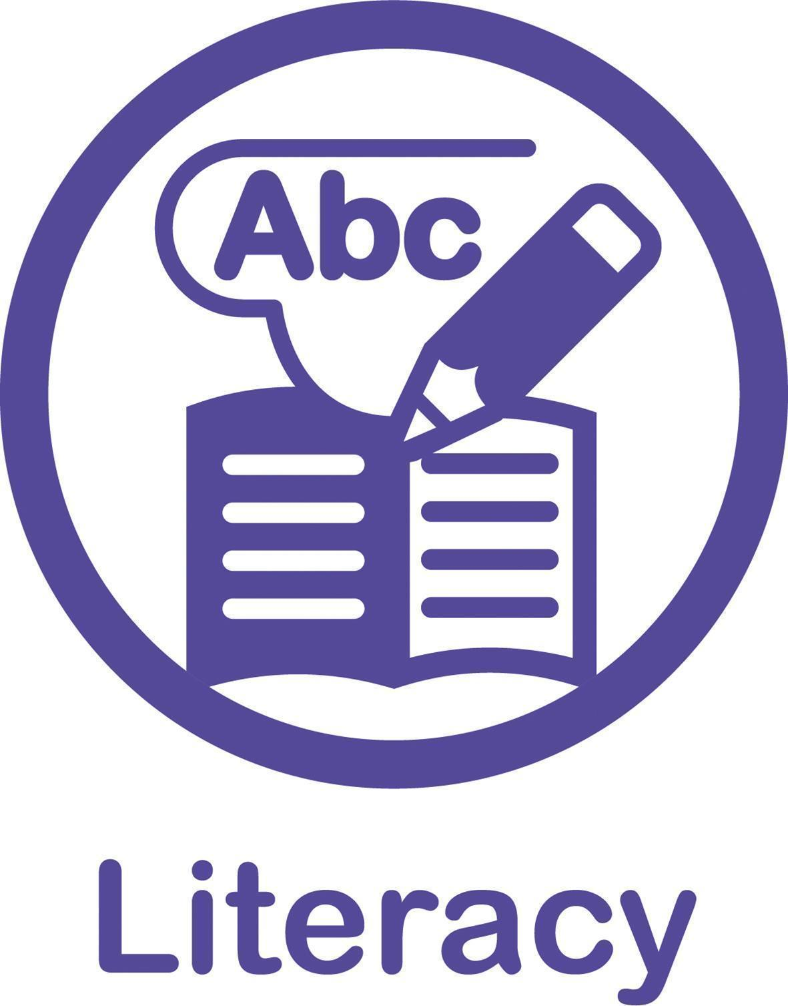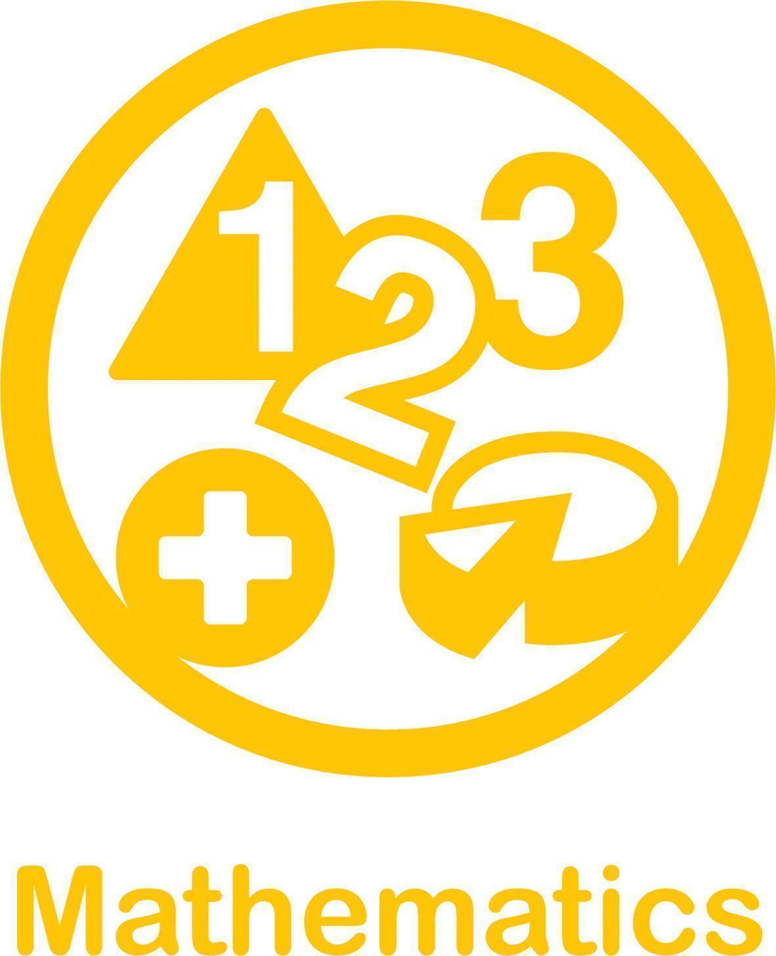
Core Books and Rhymes
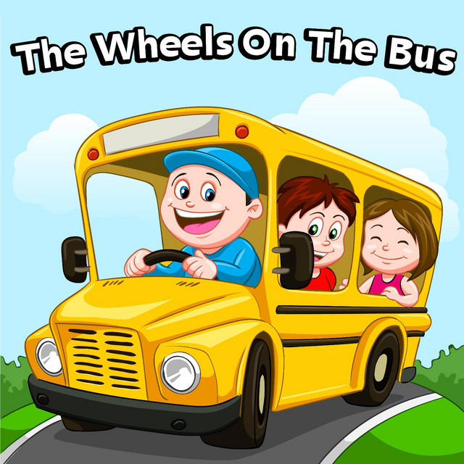
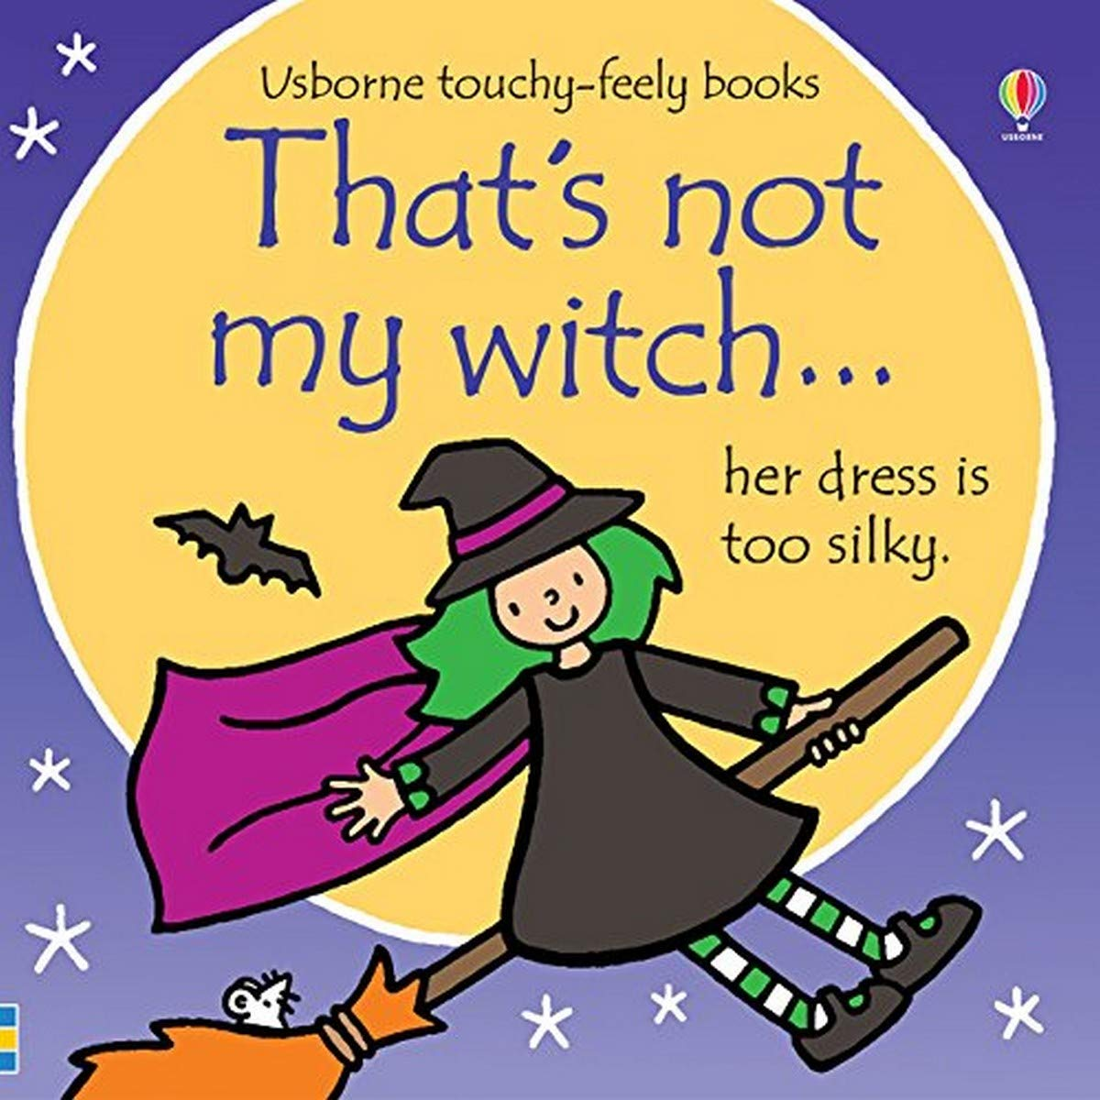

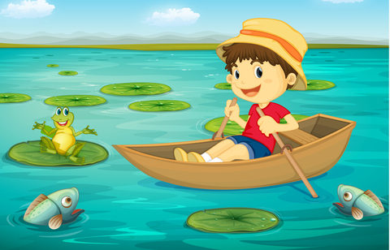
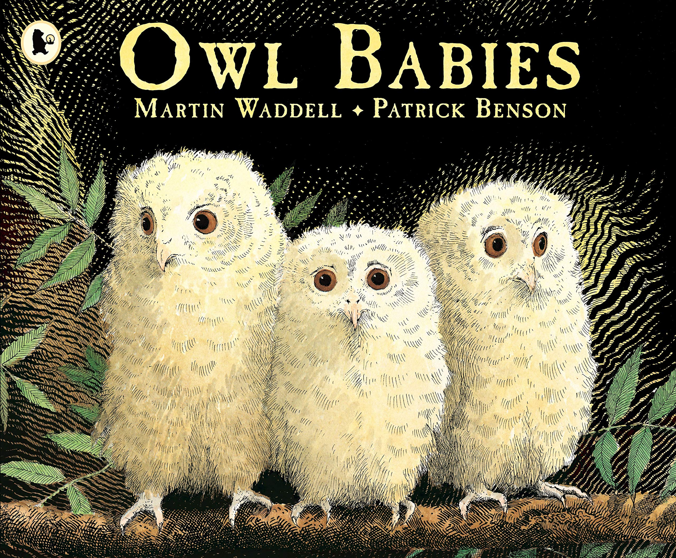
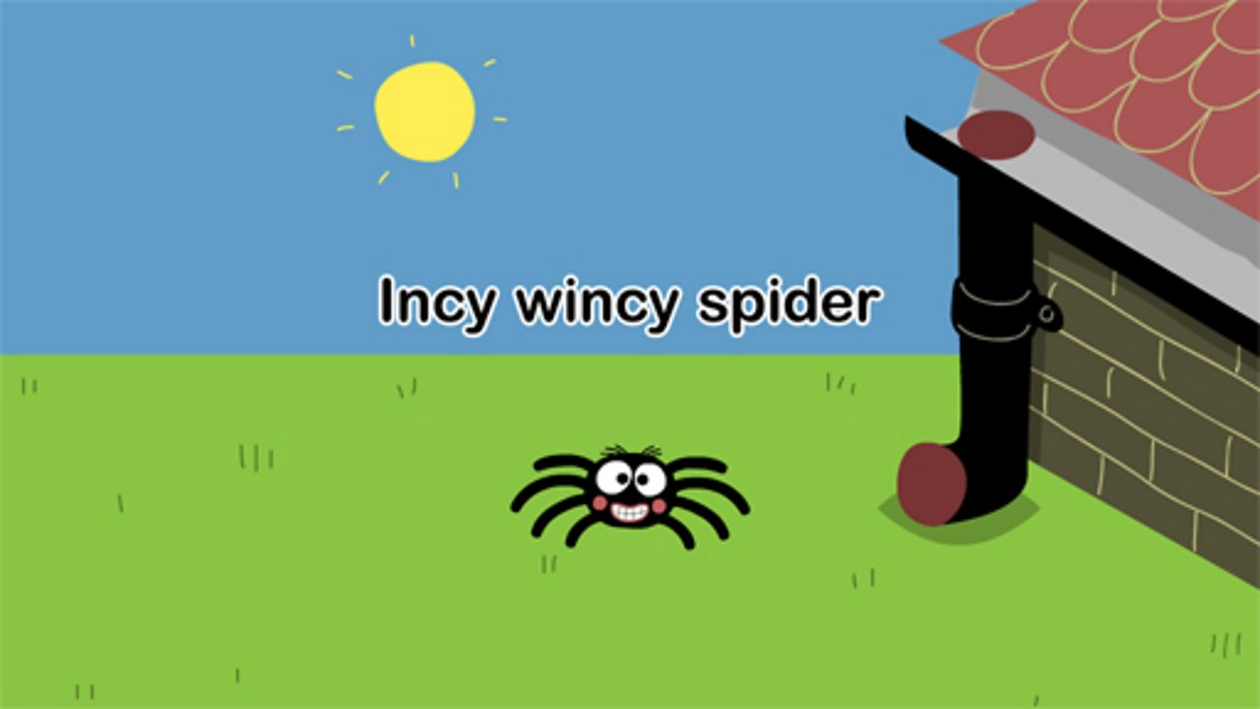
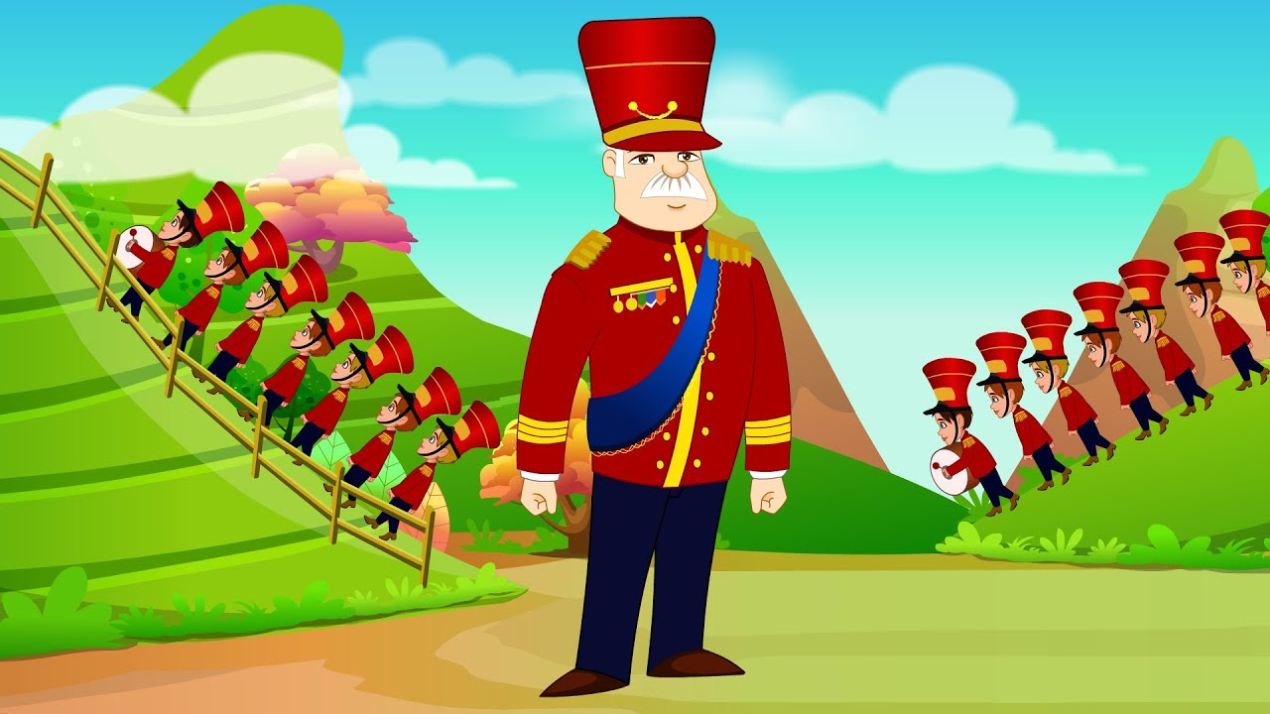

Communication and Language  - Listening and Attention and Understanding  - Speaking |  | Children's communication and language skills will be developed this term through the use of stories, songs and rhymes. The selected rhymes feature a pleasing rhythmic pattern and simple repetitive phrases that young children find easy to remember and repeat. The children will be encouraged to join in with these songs and rhymes, which will support their early phonological awareness. Key workers will support the children to learn new words and model using them in simple sentences. Key workers use Launchpad for Literacy in order to identify children’s speech, language and other developmental needs as soon as possible. They use this information, as well as ELKLAN and Early Talk Boost strategies, to inform their practice and to plan for specific early literacy intervention.
Personal, Social and Emotional Development  - Self Regulation  - Managing Self  - Building Relationships |  | Children will develop relationships with key workers from the outset. They will be supported by their key worker to gradually separate from their parents and carers. Children will become familiar with the setting and will be given opportunities to explore the indoor and outdoor environments. They will play alongside new friends and play cooperatively with key workers. Children will be encouraged to join in with group singing and games, which will provide an early step to beginning to participate socially with others. Children will also be given opportunities to explore new food tastes and textures, and learn how to look after their own hygiene needs.
Physical Development  - Gross Motor Skills  - Fine Motor Skills |  | Children are encouraged to be active on a daily basis. They will spend time exploring both the indoor and outdoor environment, where they will be able to move in a range of ways, using small and large equipment. During sensory play, children will learn to make connections between the movements and the marks they make. Physical participation in action songs will encourage children to develop their fine and gross motor control. Children access the daily circuit where they begin to develop balance, strength and coordination.
Literacy  - Comprehension  - Word Reading  - Writing |  | Children will spend time listening to and joining in with stories. They will learn to join in with songs and nursery rhymes and begin to have personal favourites. The children will begin joining in with actions and single words or short phrases to retell stories using simple story maps. Key workers will stop at intervals during stories, songs and rhymes in order to give children opportunities to say the next word. Children will enjoy mark making by exploring chalk, crayons, pencils and other media.
Mathematics  - Number  - Numerical Pattern |  | Children will begin to develop an awareness of number names through action rhymes and songs that relate to their experience of numbers. Key workers will utilise opportunities to use number names and count in everyday contexts, modelling this during play scenarios. Children will begin to recognise up to 2 simple objects, e.g. 2 hands, 2 feet. Rhyme will be used to introduce the concept of prepositional language such as ‘up’ and ‘down.’ Children will be shown how to categorise objects, for example, putting all the teddy bears together, or putting teddies and cars in separate piles. They explore size and learn words associated with size, such as ‘big’ and ‘small '. Children will be given opportunities to explore shape through inset boards and puzzles and by building simple structures and models.
Understanding the World  - Past and Present  - People, Culture and Communities  - The Natural World |  | Children will have access to containers in order to explore filling and emptying. They learn to associate a sequence of actions with the daily routine, such as snack time, story time and home time. They will enjoy sharing pictures and stories about themselves, their families and other people. Children will become familiar with the behavioural expectations, and will be supported by key workers to understand these.
Expressive arts and design  - Creating with Materials  - Being Imaginative and Expressive |  | Children learn to imitate play sequences, such as making a cup of tea and giving it to their key worker or friend. They are given opportunities to join in with dancing and ring games, and to sing a few familiar songs. Children also explore a range of sensory media and materials, both freely and with support. Key workers model how to use simple tools such as rolling pins and playdough cutters, and support children to use these independently.

